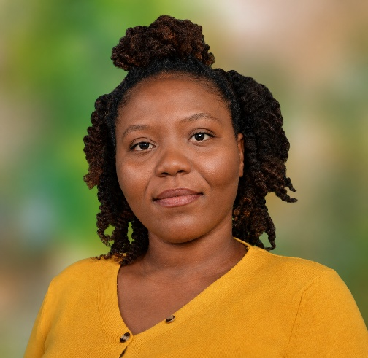
Annie Alexis
473-537-5170 | Mt. Craven, St. Patrick, Grenada

anniealexis01@gmail.com

Education:
Monroe University
2025-2026 (December)
T.A. Marryshow Community College
2014-2016

Skills:
Customer service & relationship management
Negotiation & Communication
Conflict resolution & Time management
Critical thinking & Problem solving
Multi-tasking
Advanced Microsoft Office skills
Tableau software
Data entry
Credit analysis and account management
Account reconciliation support
Loss mitigation

Debt collection\ loss mitigation

Qualifications:
Associate degree in Business Studies
Cape (A’ levels)
Business management unit 1 3
Business management unit 2 2

CSEC (O’ levels)
Mathematics 3
English Language 2
Office Administration 2
Principles of Business 2
Information technology 2
Economics 3
Social Studies 3
Human and Social Biology 2

Experience: Clear Harbor LLC
Client Services Representative ( Farmers Insurance)
October 2016- July 2020

- Managed customer accounts by processing payments, updating policy information, and maintaining accurate records.
- Coordinated policy changes, including coverage, vehicles, and driver additions or removals.
- Processed policy cancellations and ensured all requests were completed accurately and within company guidelines.
- Prepared and distributed insurance documents while maintaining compliance with company standards.
- Resolved account and billing inquiries by providing timely, customer focused solutions.
- Negotiated payment arrangements to help clients maintain continuous insurance coverage.

KM 2 Solutions
Loss Mitigation Specialist
March 2022- April 2026
- Created and managed customized payment arrangements that improved account resolution and customer satisfaction.
- Negotiated payment plans to reduce delinquent accounts and support timely payments.
- Maintained accurate records of agreements and customer account activity.
- Delivered exceptional customer service by providing solutions tailored to individual customer circumstances.
- Helped customers avoid account default by developing realistic repayment schedules.

Hobbies: Reading, Steel Pan playing, Drumming, Hiking and Volunteering

References: Dishon Edwards
T.A. Marryshow Community College
Assistant Lecturer – Department of Natural and Related Sciences
473-537-2340

Ikeiba Knight
473-421-1048

